Connecting the Gemtek Femto Gateway via WiFi Backhaul

To setup the Gemtek Gateway to use WiFi instead of Ethernet, please connect your Gemtek to power & ethernet & follow the steps below.
- Look at the bottom of the Gateway & find the AP name.
- Look for that AP name in your WiFi networks & connect to it.
- If the WiFi network does not show up, then,
  - Look for the WiFi name (SSID: AP-XXXXXX) & password on the label. Then go to your WiFi settings on Windows/Mac & manually create a WiFi network, WPA2 Security & with the info provided below:
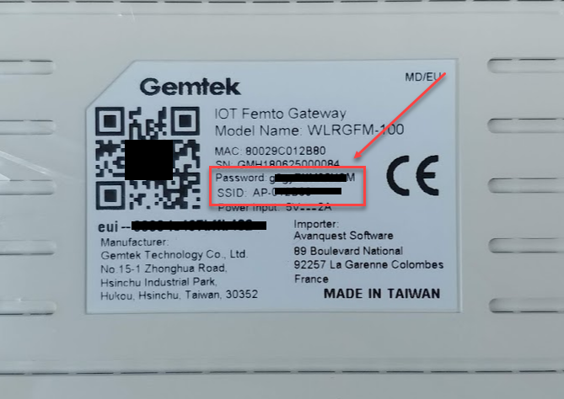
  - If no Password is provided, then the password is a7z4GBXXXX, with the “XXXX” being the last 4 digits of devEUI. For example a7z4GBb432.
- Once you have connected to the AP-XXXX network, open a web browser & visit 192.168.55.1
- You will then need to login as
Username: admin
Password: admin (or password from bottom of the label).
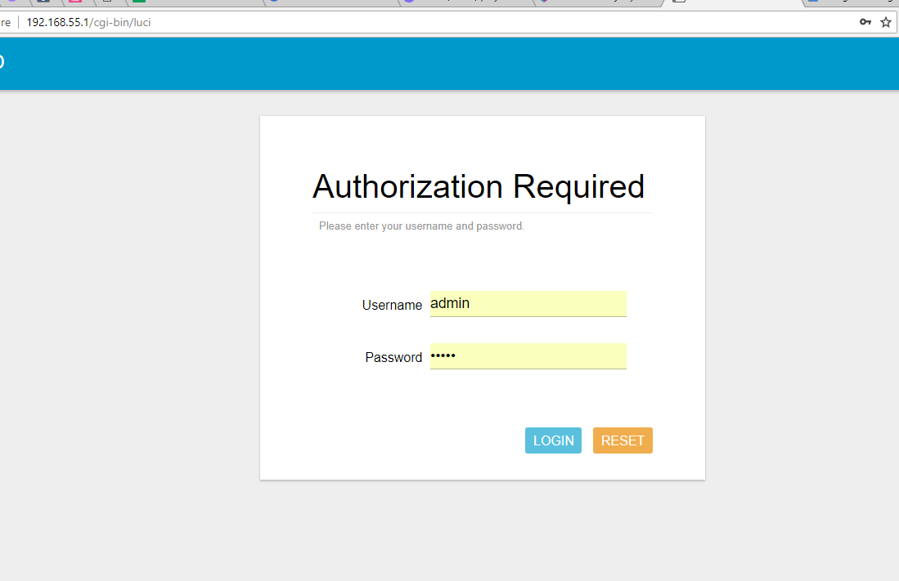
- On the left hand side, click on Network > WAN > Wireless Extender.
- On Extender mode, change it to “Enable”.
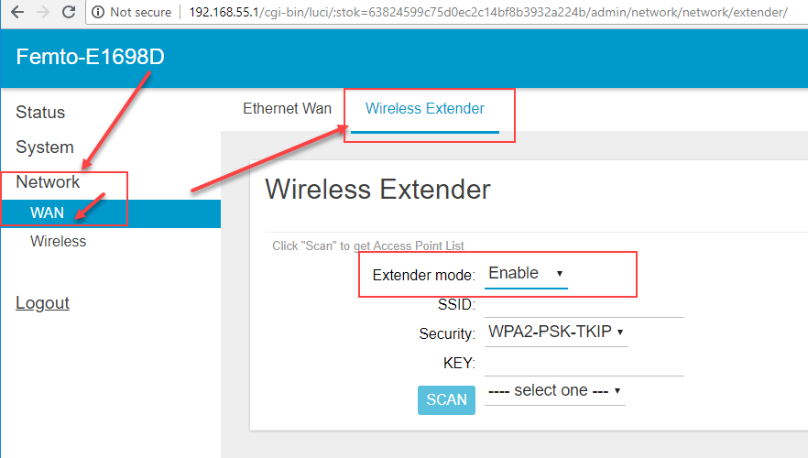

- Click the “Scan” button, then you click click on “--- select one ---” to view the available networks
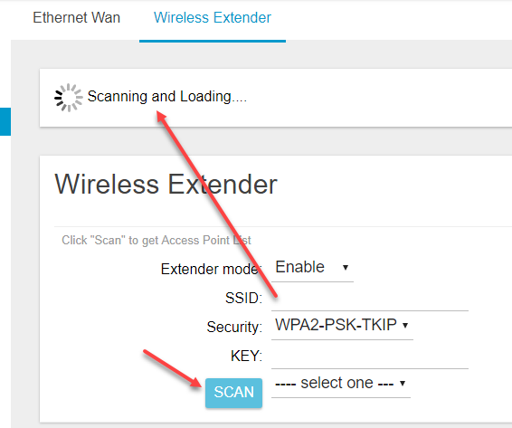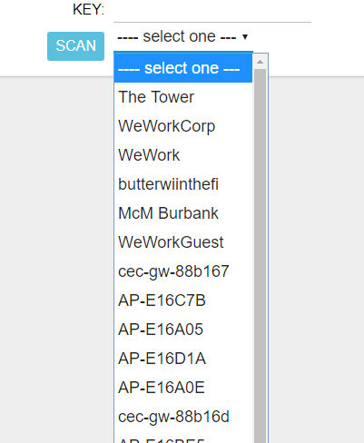
- Next, select the desired network, type in the WiFi Password as the “KEY” and click “Save”.
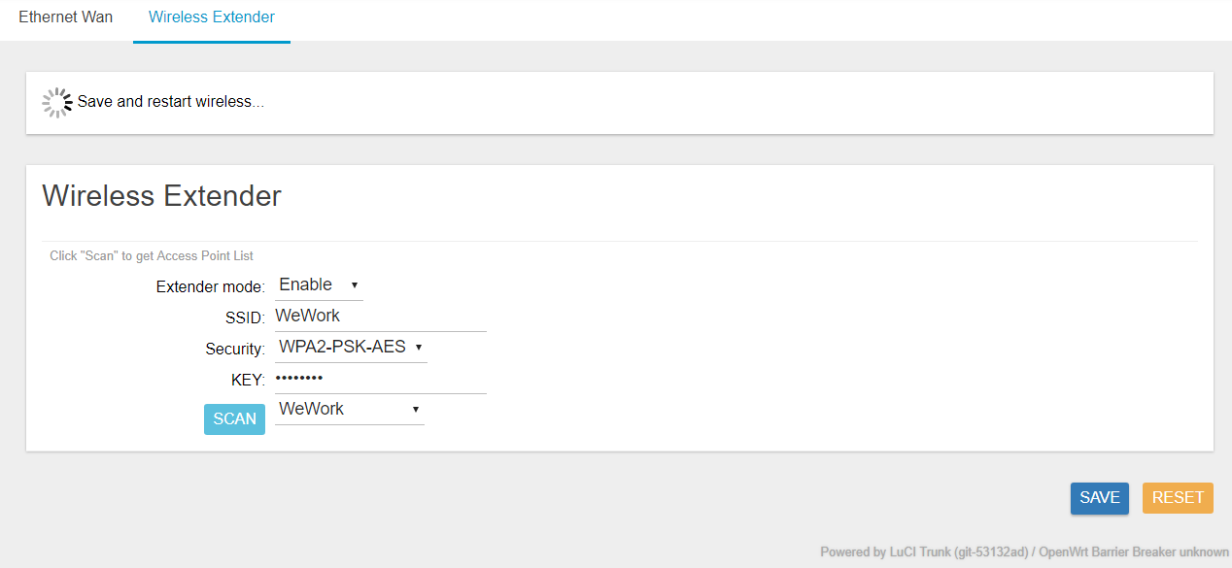
- This will effectively reset the gateway & kick you off the WiFi connection you were on.
- Now you can disconnect the Gateway from Ethernet & check to see if it stays online on the IoT in a Box app.

If you encounter any issues, please submit a ticket via help.mydevices.com

