# Connecting the Gemtek Femto Gateway via WiFi Backhaul

To setup the Gemtek Gateway to use WiFi instead of Ethernet, please connect your Gemtek to power & ethernet & follow the steps below.

1. Look at the bottom of the Gateway & find the AP name.
2. Look for that AP name in your WiFi networks & connect to it.
3. If the WiFi network does not show up, then,
   1. Look for the WiFi name (SSID: AP-XXXXXX) & password on the label. Then go to your WiFi settings on Windows/Mac & manually create a WiFi network, WPA2 Security & with the info provided below:

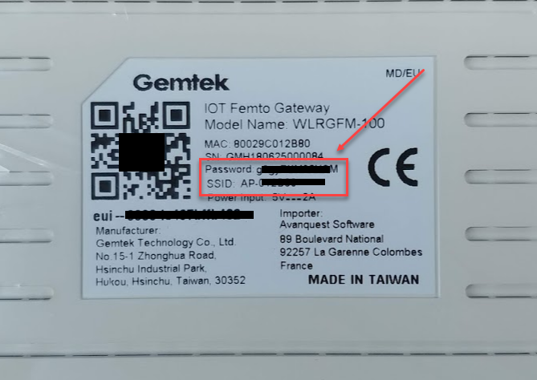

* 1. If no Password is provided, then the password is **a7z4GBXXXX,** with the “**XXXX**” being the last 4 digits of devEUI. For example **a7z4GBb432**.

1. Once you have connected to the AP-XXXX network, open a web browser & visit **192.168.55.1**
2. You will then need to login as  
   Username: admin

Password: admin (or password from bottom of the label).

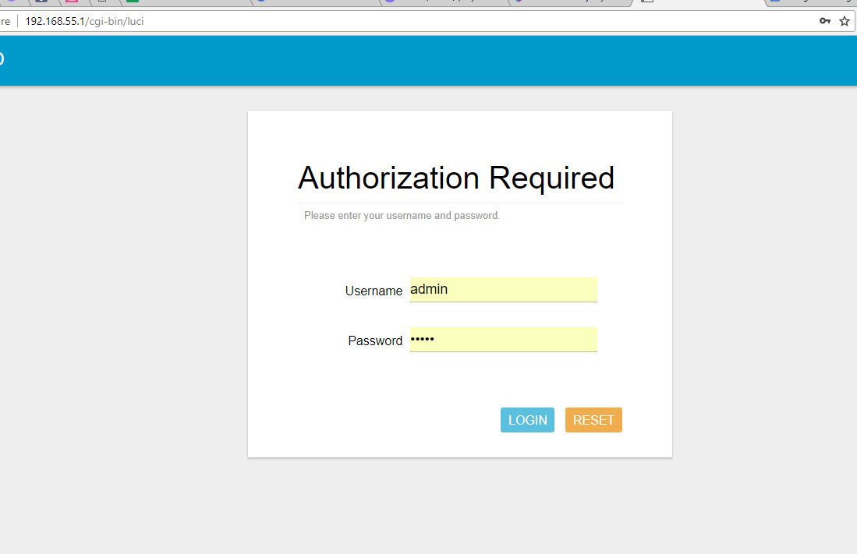

1. On the left hand side, click on Network > WAN > Wireless Extender.
2. On Extender mode, change it to “Enable”.

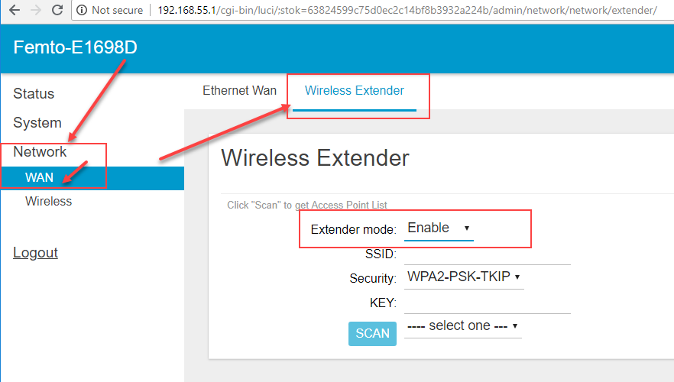

1. Click the “Scan” button, then you click click on “--- select one ---” to view the available networks  
   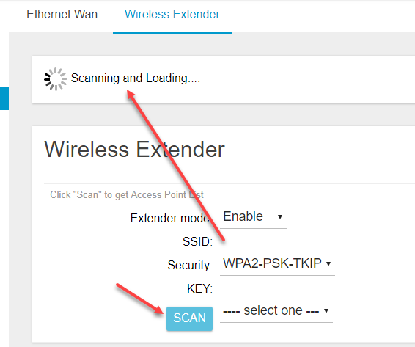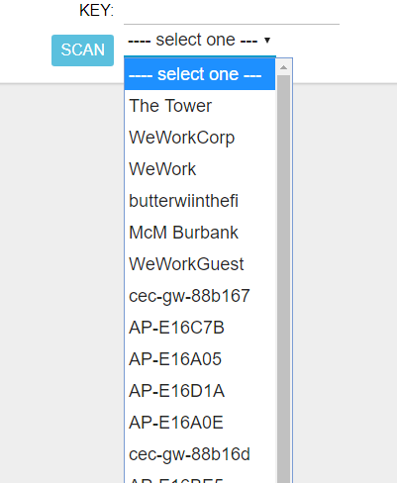
2. Next, select the desired network, type in the WiFi Password as the “KEY” and click “Save”.  
   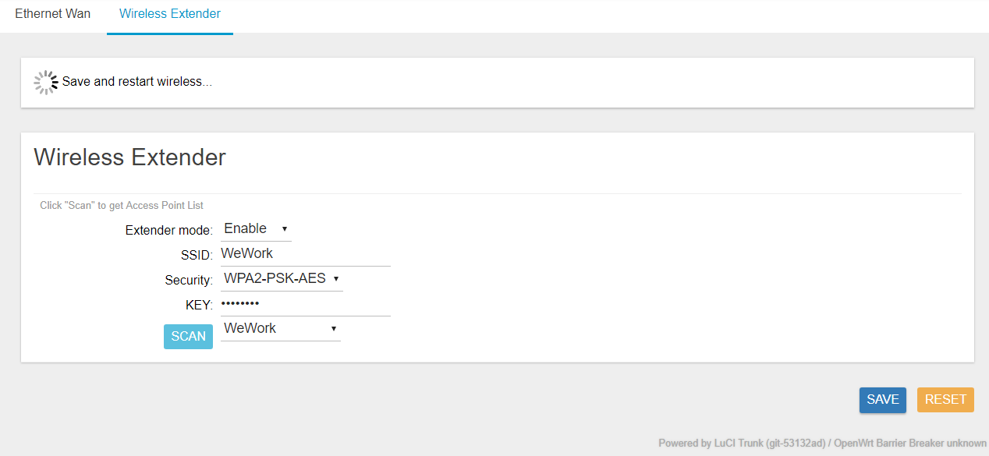
3. This will effectively reset the gateway & kick you off the WiFi connection you were on.
4. Now you can disconnect the Gateway from Ethernet & check to see if it stays online on the IoT in a Box app.

If you encounter any issues, please submit a ticket via [help.mydevices.com](http://help.mydevices.com/)